Colour & Colláge – Art creations of John Phillip Holland the designer of the first Modern Submarine

The following pictures are of John Phillip Holland with the submarine that he designed called Holland I.

Instructions:
The pictures below have been created into outline templates for you to use.
Using paints or colouring materials, fabrics and fibre and create a painting or a colláge work of John Phillip Holland and his submarine.

Include a title at the top of the picture.

Describe your picture in the box below the template explaining the materials that you have used. Find out an interesting fact about John Phillip Holland and include it in the description of your artwork.

Materials:
Paper / card
Fabric – old clothes, socks, lace, different types of materials
Fibre – wool, string, cotton etc
Recycled items – anything goes including wrappers, plastics, cardboards, cans etc
Oher house hold items – buttons, dried pasta, copper wire etc
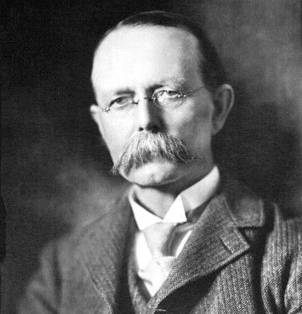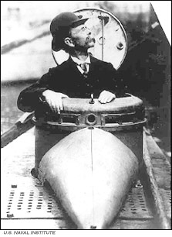

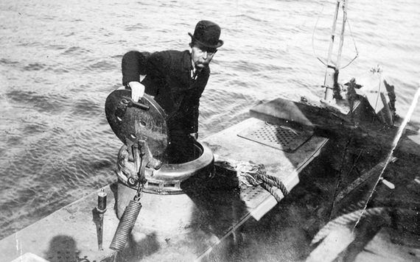

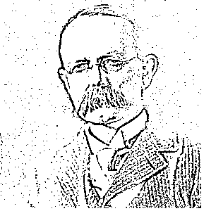

Materials that I have used in my collage and facts about John Phillip Holland: ___________________________
___________________________________________________________________________________________
___________________________________________________________________________________________
___________________________________________________________________________________________
___________________________________________________________________________________________
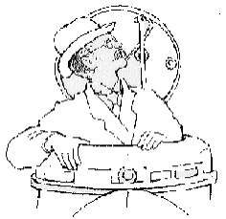

Describe the materials that you have used in your collage: ___________________________________________
___________________________________________________________________________________________
___________________________________________________________________________________________
___________________________________________________________________________________________
___________________________________________________________________________________________

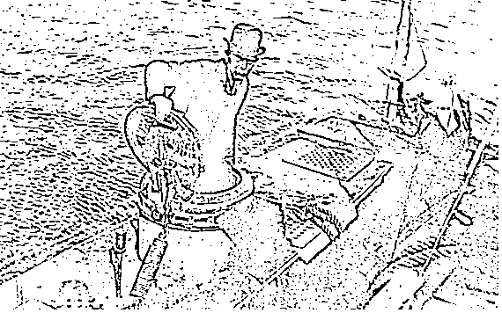

Materials that I have used in my collage and facts about John Phillip Holland: ________________________________________________________________
______________________________________________________________________________________________________________________________
______________________________________________________________________________________________________________________________

